* **ASP .NET CORE (MVC) WEB APP DEPLOYED ON AZURE VM**

First step -Create an Azure Virtual Machine:

* + Log in to the Azure portal (portal.azure.com).
  + Click on "Create a resource" and search for "Windows Server" or the desired operating system.
  + Select the appropriate virtual machine configuration and follow the prompts to create it. Make sure to select the desired VM size, storage, and networking options.

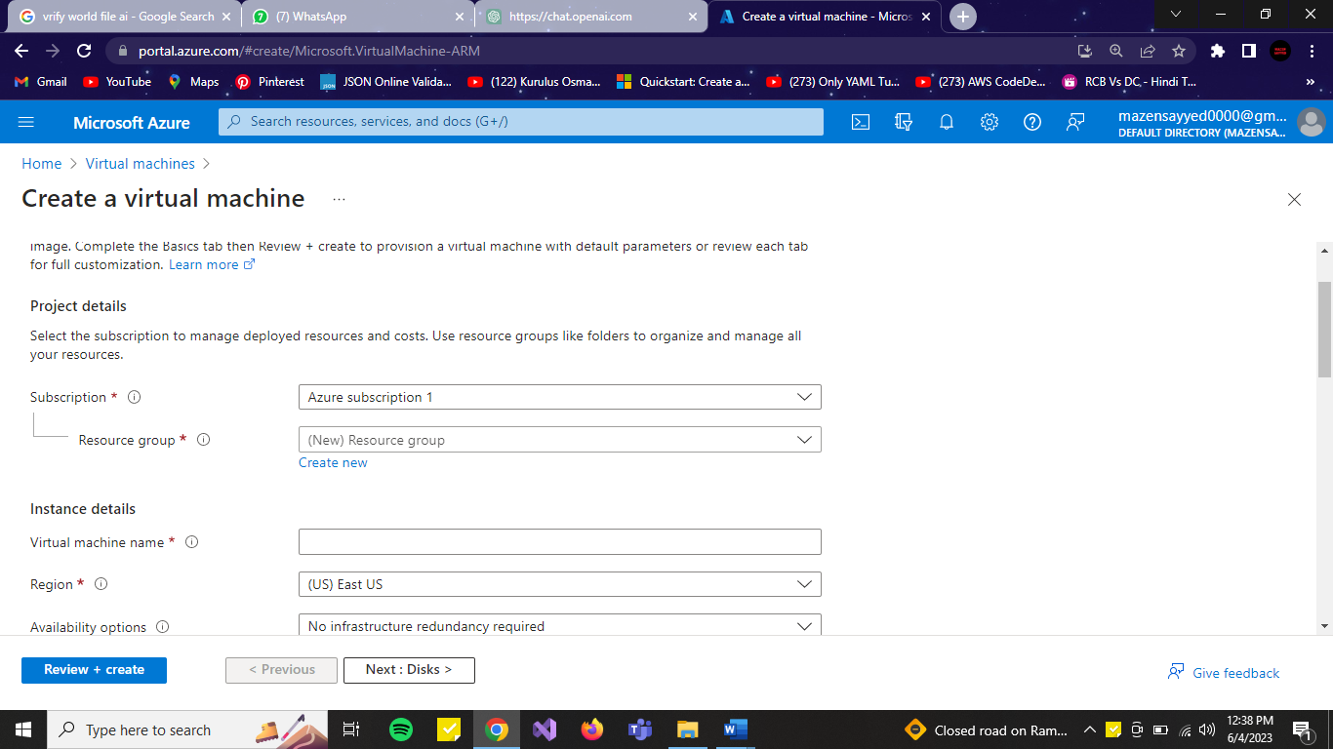

* Once the VM is created, wait for it to be provisioned.
* Connect to the VM using Remote Desktop.
* Install the necessary components for hosting ASP.NET applications on IIS, including the .NET runtime and IIS features.
* Once the VM is created, wait for it to be provisioned.
* Connect to the VM using Remote Desktop.
* Download and install the .NET 6.0 runtime on the Azure VM. You can download it from the official Microsoft website: <https://dotnet.microsoft.com/download/dotnet/6.0>

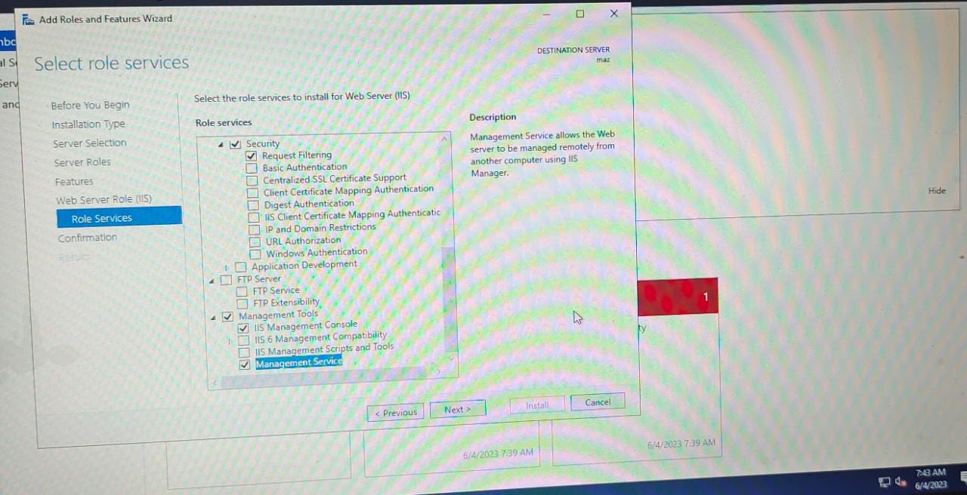

1. Create an ASP.NET Core MVC project in Visual Studio:
   * Launch Visual Studio and select "Create a new project."
   * Choose the ASP.NET Core Web Application template and select "Next."
   * Provide a name, location, and other project details, and then select "Create."
   * Select the "ASP.NET Core Web Application" template, choose the desired version, and select "Create."

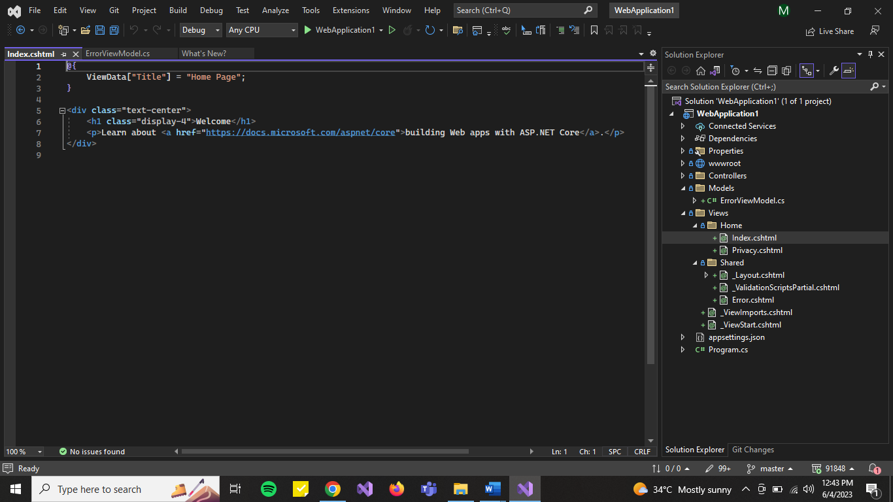

1. Prepare your .NET Web Application:
   * Build your .NET web application using Visual Studio or another build tool. Make sure it generates the necessary artifacts for deployment, such as the compiled binaries and any required configuration files.
   * Open Visual Studio and click on "Sign in" in the top right corner to sign in to your Azure account.
   * After signing in, click on the "Cloud Explorer" button in the toolbar to open the Azure Explorer window.
2. Create an Azure Repository:
   * In the Azure Explorer window, right-click on "Azure Repos" and select "Create Repository."
   * Follow the prompts to create a new repository in Azure. Provide a name and select the appropriate settings for your repository.
3. Verify the Push:
   * Go back to the Azure Explorer window in Visual Studio.
   * Navigate to the Azure repository where you published your application.
   * Verify that the code files and any necessary artifacts are present in the repository.

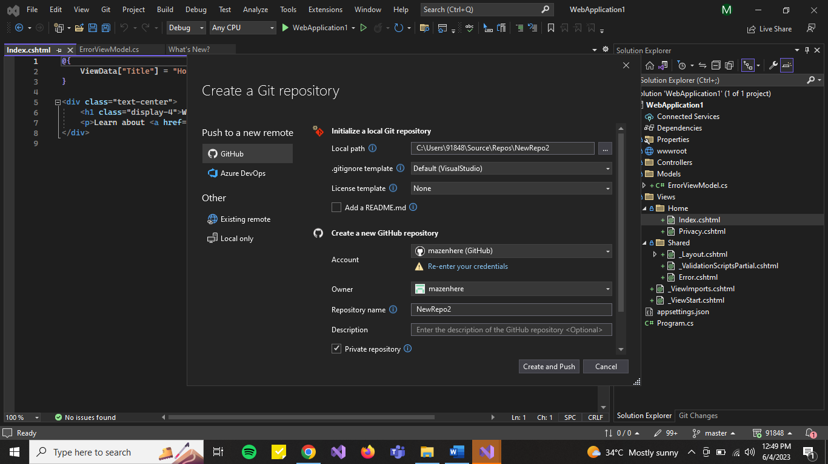

1. Then, go to pipeline select New Pipeline, and continue with [Use the classic editor](https://dev.azure.com/vishwajitadcet/vishwajit-project/_apps/hub/ms.vss-ciworkflow.build-ci-hub?_a=build-definition-getting-started&id=0) to create a pipeline without YAML.
2. Then, select **Continue**

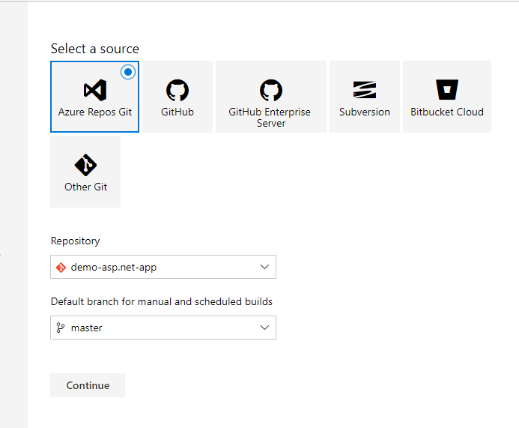

1. Search for **ASP.NET Core** ….. and Apply.

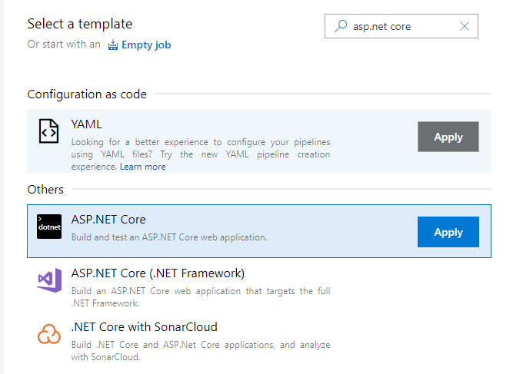

1. Select Agent Pool to Default . and select = **Save and Queue.**
2. Wait for to complete Build.

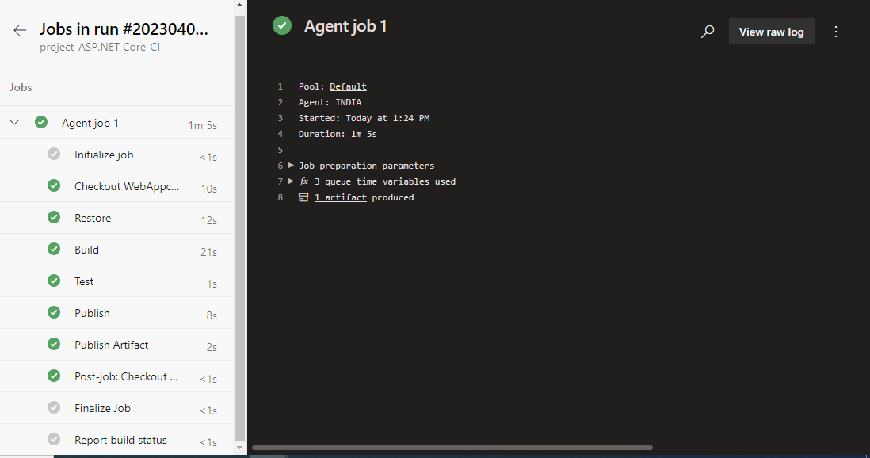

1. Go to Deployment Group

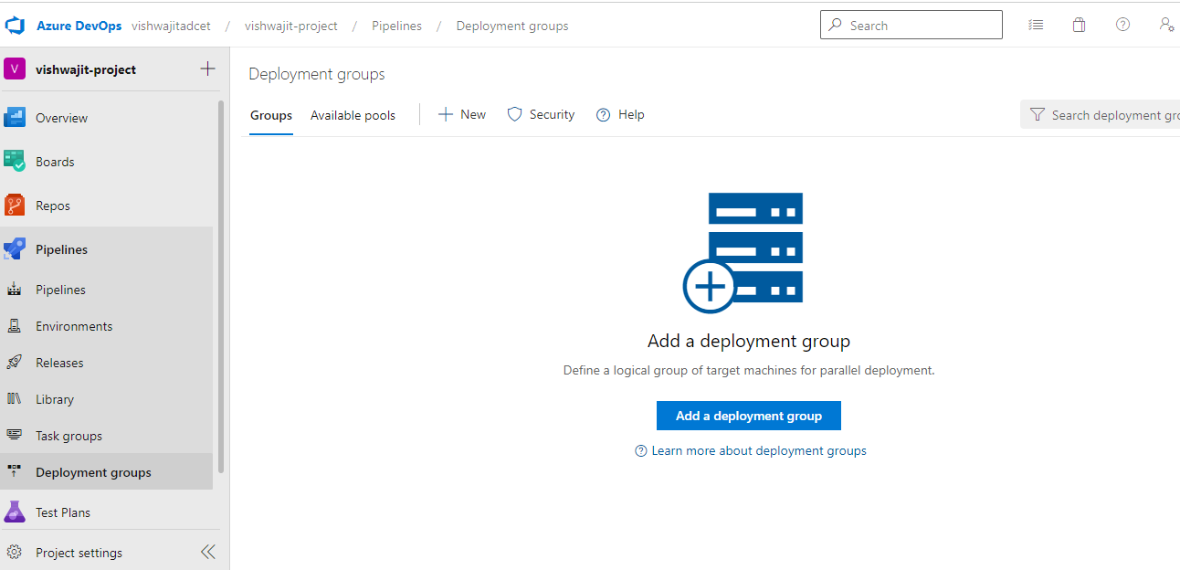

And app a deployment group and give name for deployment group .

And copy the PowerShell Script **with use PAT in script** as shown in following screenshot .

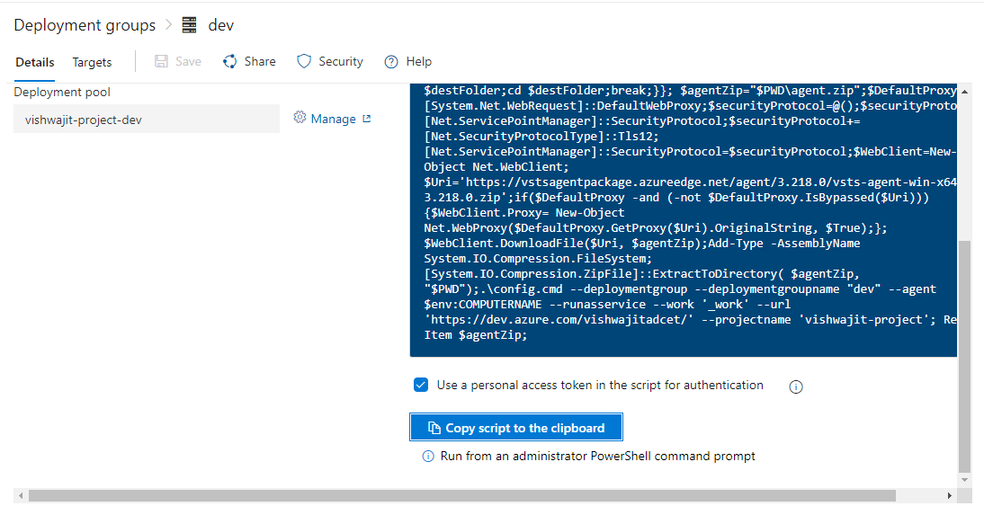

1. Then go to azure portal and launch one simple virtual machine (VM) and after open VM. Once vm starts then open PowerShell with Administrator mode, and paste above code and run it. Press **Enter** for all questions asking when running above script.
2. Then, come back to Azure DevOps tab/page and go to release pipeline and select new release pipeline, after that select Empty job and save it.

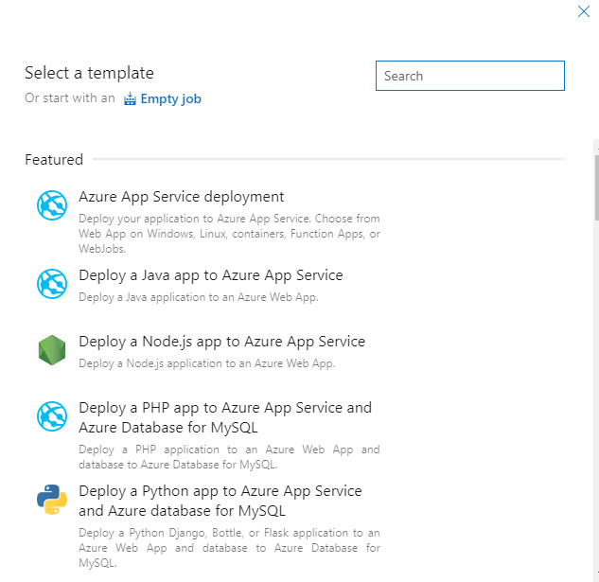

After that click on **1 job 0 task.**

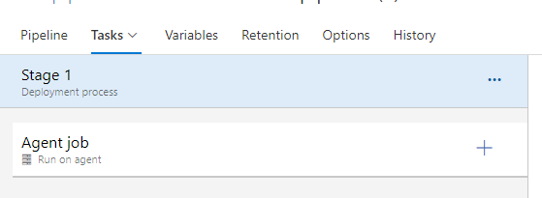

1. Click on three dots which is in front of stage 1 in that there is one option

Add deployment group job select that option.

Select Agent job and remove it.

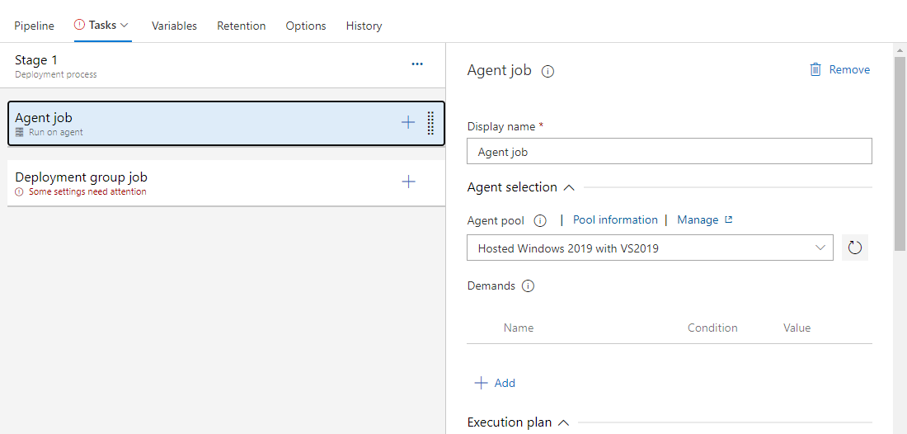

Then select your deployment group and add 2 task-- 1) iis web app manage.

2) iis web app deploy.

1. In iis web app manage **mark the enable iis** for automatically install iis server.

And give **website name** like-Default web site.

1. ***Do same step (website name) for second task.***

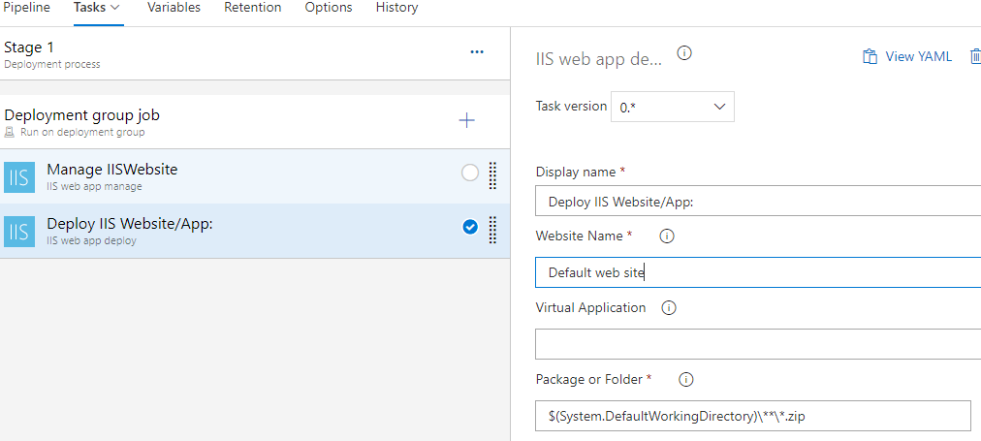

1. Then add one more task **install .net core runtime and hosting bundle.**

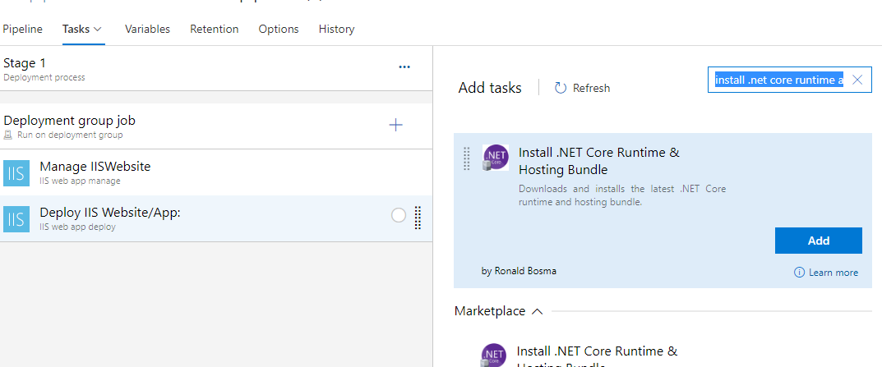

1. In third task change the version to 6.0 (which is similar to your app code which is created in Visual Studio.) like below—

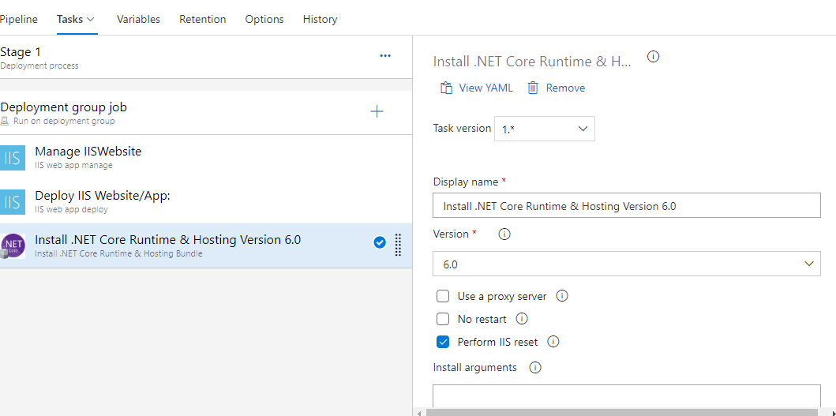

1. Then **save** and **create release pipeline**.
2. Monitor logs, after completing release pipeline

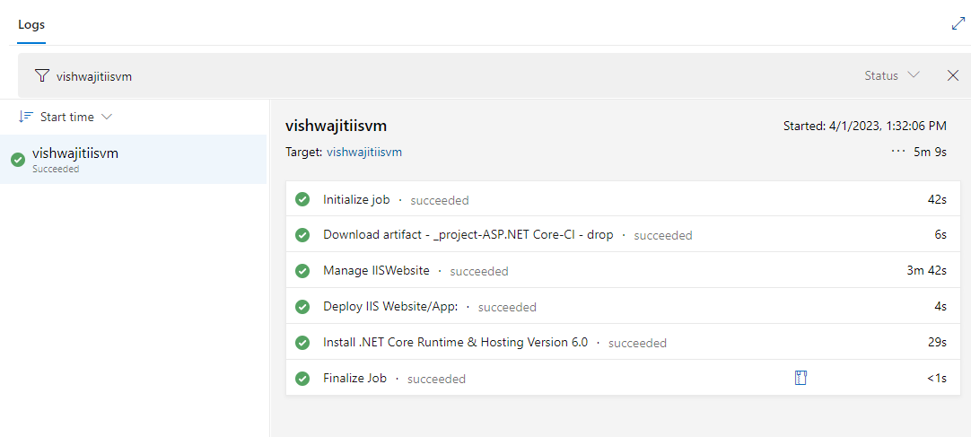

1. copy IP address of your virtual machine and paste it new tab ….. here is Result.

